Introduction to Building Projection-based Tiled Display Systems

Mark Hereld,¹ Ivan R. Judson,¹ Rick L. Stevens^{1,2}

{hereld, judson, stevens}@mcs.anl.gov
Mathematics and Computer Science Division
Argonne National Laboratory¹

Computer Science Department
University of Chicago²

Introduction

In this paper we introduce the concepts and technologies used to build tiled display systems. The motivations for construction of tiled displays are manyfold. For some applications one is limited by the resolution of today’s single displays. In other applications the desire is to produce a large-format display with high resolution per unit area. And in others there is interest in embedding the display into the working environment in a way that the display becomes an extension of the traditional desktop display environment.

Tiled displays are an emerging technology for constructing semi-immersive visualization environments capable of presenting high-resolution images from scientific simulation [EVL, PowerWall]. In this way, they complement other technologies such as the CAVE [Cruz-Niera92] or ImmersaDesk, [Czernuszenko97], which by design give up pure resolution in favor of width of view and stereo. However, the largest impact may well be in using large-format tiled displays as one of possibly multiple displays in building “information” or “active” spaces that surround the user with diverse ways of interacting with data and multimedia information flows [IPSI, Childers00, Raskar98, ROME, Stanford, UNC]. These environments may prove to be the ultimate successor of the desktop metaphor for information technology
work.

Several fundamental technological problems needs to be addressed to make tiled displays practical. These include (1) choice of screen materials and support structures, (2) choice of projectors, projector supports, and optional fine positioners, (3) techniques for integrating image “tiles” into a seamless whole, (4) interface devices for interaction with applications, (5) display generators and interfaces, and (6) display software environment. We will briefly touch on these topics in the next sections. Each of the in-depth research papers in this special issue covers a distinct approach to each of these problems.

Screen Materials

When constructing a tiled display system the first step is to choose a screen material. Most tiled displays are designed to be rear projected. This is not a requirement, but the display geometries are greatly simplified if simple projector throw can be used. Therefore, we limit our discussion to screens that support rear projection. Various rigid and nonrigid screen materials are available. The primary criteria for choosing screens include image performance (e.g., brightness, resolution, angle of view, contrast ratio), availability of large seamless sheets, type of mounting method, suitability for touch screen applications, rigidity (or degree of self-support in large-span applications), weight, fragility, portability, and cost. As a result of the popularization of rear-projected large-format home entertainment systems, there is an increasingly large market for advanced-projection screen materials [JenMar]. However, these materials often are available in limited sizes and may be optimized for non-overlapping or single-projector applications (e.g., requiring a Fresnel lens for increased viewing angle support). In addition to physical constraints, for example, if a system must be moved, then one needs to use a lightweight screen and lightweight mounting system (see figure 1). This would probably indicate using a flexible fabric screen material and a tension-based mounting system. If the geometry is not planar, then one may need to build the screen in segments or use flexible screen that can be bent or stretched [Stewart].

For permanent installations more options are available. The best image quality requires matching the screen with the projectors; in particular, the color balance and dynamic range of the screen need to be matched with the projectors. For materials that are not available in arbitrary sizes, some form of physically tiling the screen is needed. Tiling the screen may require very rigid mounting structures to ensure that joints are as seamless as possible and that the screen remains stable over time. Some of these structures can weigh hundreds of pounds and become part of the room’s physical infrastructure. In some instances screens can be designed into new construction.

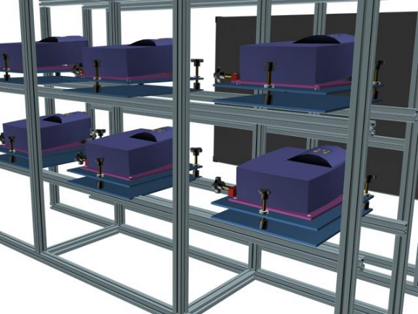
Figure 1. Rendering of a partial model of the μMural, from behind. This shows the details of the projector support structure and the projector positioners. These systems are used to align the projected images from each projector at the screen surface, visible in the rear of the image.

Projectors

The choice of projectors is perhaps the most difficult decision, partly because they represent potentially the most expensive subsystem (depending on the display generator), but also because the number and variety of manufacturers are great. The international InfoComm conference is a good source for the latest in projector technology [InfoComm]. For purposes of this paper we categorize the projectors into three classes: (1) low-cost LCD or DLP projectors designed for the high-volume portable business-presentation marketplace, (2) multichip LCD or DLP projectors designed for permanent multimedia installations, and (3) high-end projectors designed for large-venue professional imaging marketplace using a variety of high-quality and high-performance image modulation technologies (CRT, LCD, DLP, Lightvalve, etc.). Another way to distinguish between these is by price: less than $8K, $8K-$20K, and greater than $20K. Since this paper is concerned with leveraging commodity or near-commodity components, we will focus on the first case, but we will also address a few issues relating to the other projectors. Properties important for projectors include resolution, brightness, color gamut, data interfaces, image quality, optical quality, noise, remote control interfaces, software controls, calibration and configuration control, stability (zoom, focus), image refresh rate and support for stereo, resampling algorithms (e.g., automatic resolution conversion), flatness of illumination field, keystone correction or off-axis projection capability, color convergence, image alignment or adjustment and power, cooling weight and size.

Current low-end projectors support native resolutions of 1024x768 pixels, with a move to 1280x1024 expected in the near future. Brightness is typically in the 500-1000 lumen range, which is sufficiently bright that an 8- or 15 projector rear-projection array will have no problem being viewed in a fully lighted room. A critical feature for tiling applications is the flatness of the illumination field (brightness falloff from the center of the image to the edges). Ideally the illumination field would have no falloff; in practice, falloff is one of the key image quality factors that must be addressed to create seamless displays.

Color gamut (the range of colors supported by the device) is also important, as is color uniformity or matching of colors between projectors. Depending on the application, color gamut testing might need to be done prior to projector selection. Color calibration and color gamut matching between projectors are important. Low-end projectors often have limited color correction capability and a high-degree of color gamut variability between projectors. As a result, a tiled display can be limited in its ability to achieve matched colors between tiles. Higher-end projectors tend to have more color calibration capability and are more likely to be color matched between projectors.

Data interfaces to the projector are also an important factor in image quality. Analog RGB inputs can suffer from cable noise
and pose problems in video formatting when switching between different input sources, often requiring video format adjustments in the projector to preserve framing. Digital video interfaces are just now becoming available that offer the potential to address the noise and video format issues. It is important that the projectors provide a control interface and API that permits setting and changing projector parameters via a serial interface or other computer-based control that can be automated.

Low-end projectors often have relatively simple optics and should be tested for image quality (flatness of focus, sharpness, image distortion, etc.). A zoom lens can enable flexible throw distances but also creates the potential for instability if the zoom is power driven and cannot be manually locked. For multiple-chip projectors, color convergence (alignment of the subpixel color components into a focused pixel) is also important for image quality. Higher-end projectors often support convergence adjustments.
Over time, projectors and bulbs age, thereby affecting both color and brightness.

Projectors also vary in image refresh rate and support for stereo. Current low-end projectors typically cannot refresh fast enough to support field sequential stereo (80-100 fps). Often the multiresolution resampling engine that enables variable input display resolution runs more slowly than the image modulator, and this limits stereo capabilities. An effort to identify and prioritize these critical issues for next generation projector designs was started with the first ASCI Advanced Projector Workshop [OpenProjector00].

Blending, Alignment, and Calibration

Image blending, alignment, and calibration are the key major technical challenges to producing practical tiled display systems. The goal of a high-resolution scalable display surface demands that we address the issues of how to transform a collection of separate tiles into one seamless display. Work in this area centers on the following primary problems: (1) image and projector alignment, (2) color and luminosity matching, (3) edge blending, and (4) calibration techniques.

Image and Projector Alignment. When tiling a surface, the tiles must be accurately aligned so that accumulated alignment errors do not propagate to the point where the overall geometry is distorted. The situation is analogous to tiling a floor while maintaining the rectangular boundary conditions. For displays this means being able to control the projector and subsequently the image placement and attitude in all six degrees of freedom, in order to make the tiles uniform in shape and scale. Such alignment often is accomplished by mounting the projector on a positioning device. Intel and Princeton have developed a 6 degree of freedom mechanical positioner for mounting portable projectors (see figure 4). Argonne has improved it’s kinematics and made it more compact (see figure 2). Livermore has used commercial projector mounting system for its larger CRT projectors.

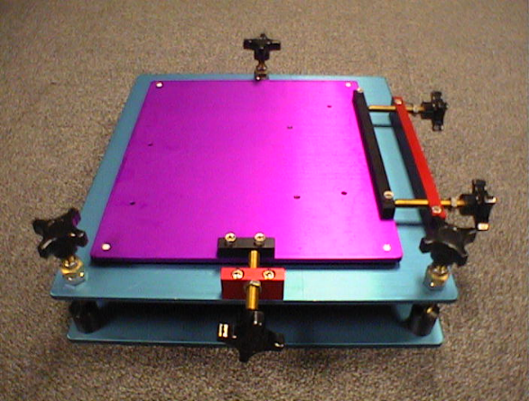
Figure 2. Projector positioner with 6 degrees of freedom, designed at Argonne. The top purple plate of this positioner has mating holes drilled to fit a Proxima DX1 projector.

In practice, it is difficult to achieve subpixel alignment even with fine adjustment in each dimension. MIT and UNC have developed software approaches to automatically “distort” the images prior to projection to match edges using calibrated cameras [Surati99, Raskar99]. Princeton has extended the ideas to work with uncalibrated cameras [Chen00a]. This technique is used in addition to mechanical alignment, the processing of the images may introduce however a performance penalty. University of North Carolina’s Office of the Future Group are exploring physical “freeform” projector placement and are handling image alignment completely in software [Raskar98, Raskar99]. One interesting possibility is video-based closed-loop servos that can automatically a
lign projectors after configuration changes. Current manual approaches to alignment begin to become difficult at 15 projectors. Displays with 20 or more projectors will probably need some form of automated alignment capabilities.

Color and Luminosity Matching. A major difficulty when tiling with lower-end projectors is the high degree of color and luminosity variability inherent in these near-commodity products. One approach is to carefully sort projectors and bulbs to select a subset of devices that are as close as possible. This approach is highly recommended. Once the gross variation has been eliminated, however, considerable color variability may still exist between neighboring projectors from the manufacturer and of the same model. Manual adjustment of color using the built-in color adjustments may be adequate. For large-arrays it becomes nearly impossible to converge color adjustments manually. Multiple groups are therefore developing automatic or semiautomatic color-matching techniques that use colorimeter or digital camera inputs and closed-loop optimization algorithms to calibrate and correct the illumination reaching the screen. Groups at UNC [Majumder00] and Princeton [Li00] have reported methods for correcting the image computationally before sending it to the projectors, while Argonne [Hereld00] and LLNL [Schikore00] are developing techniques for adjusting the projector characteristics. Similar strategies can be applied to matching brightness across the array of projectors. Moreover, luminosity falloff within a single tile may need to be addressed by computing an inverse filter and applying that at rendering time, perhaps by using an alpha channel.

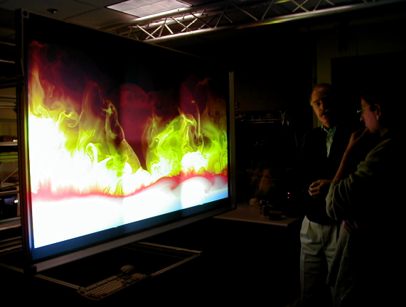
Figure 3. Users view the progression of a high-resolution movie on the μMural. The movie is of a two-dimensional simulation of an X-ray burst on the surface of a neutron star. The data for the movie was in part generated by the DOE-supported ASCI Alliance Center for Astrophysical Thermonuclear Flashes at the University of Chicago.

Edge Blending. Merging multiple images together to create a seamless image requires overlapping image tiles and blending the images to create a seamless transition from one tile to the next. The issues were first laid out in work on overlapping projection onto domes [Lyon85, Lyon84]. A number of ways to attack these problems have been further developed. One can align projectors to create a fixed overlap region between adjacent images and modify the signal to each projector to blend the images in the overlap region by applying a virtual shadow mask [Inova88]. This effect can be achieved in signal electronics [Panoram, Trimension] or in software [Surati99, Raskar99]. There are several difficulties with this approach. The human eye is sensitive to the exact nature of the slope of the falloff curve, and artifacts can be introduced. Another potential difficulty is the computational cost to apply this mask unless it can be computed once and applied via hardware. Furthermore, screen materials will have viewing angle dependencies that alter the apparent falloff rate in the overlap region.

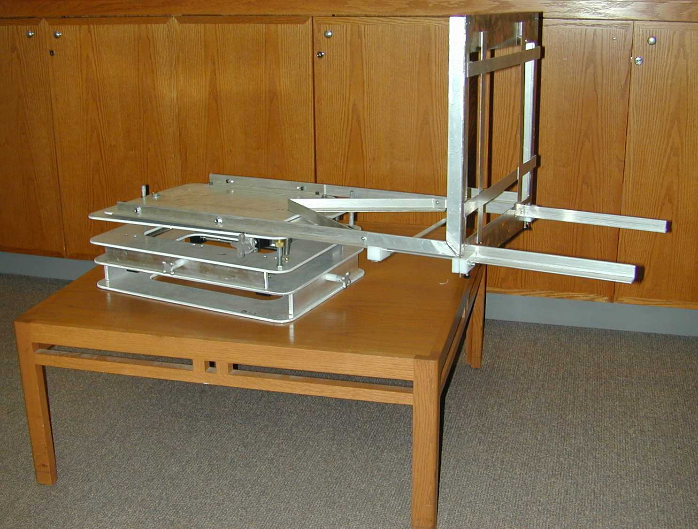
Figure 4. Intel-Princeton projector positioner with aperture modulation frame. The magnetically attached vignetting blades are easily adjusted.

One important observation is that some imaging technologies (e.g., LCD) cannot produce true black. In these cases software-only approaches cannot address the residual additive effects of stray light, further reducing the contrast ratios of the image. This has the effect of graying the overlap region of the images. Some groups have simply used as accurate an alignment as possible to abut images and have found this quite satisfactory, particularly where high-end projectors were used that have superior color matching and flat illumination. An alternative is to use physical shadow masks [Li99] to obscure the projected image in the overlap region, create a feathered edge to the projected image, and adjust the masking distance and edge geometry to achieve a blended image without modifying the source image (see figure 4). This has the advantage of being fast, but it requires more complex projector light paths and structures.

Calibration Techniques. While it is possible today to manually align, blend, and balance an array of a dozen or so projectors, this is a time-consuming process easily taking one or more days of effort. Changes in configuration require this process to be repeated fairly often and in addition the systems can drift out of alignment or lose color settings if powered off or reset through software. For tiled displays to become a practical, widely deployable technology, calibration must become an automated process that can be run as often as necessary depending on the environment and configuration. By incorporating cameras into the environment and automating control of projectors and positioners, it will become possible to test a variety of automated calibration schemes.

User Interface Devices

The tiled display is by design an environment that is of larger scale than the desktop, whether it is a 6-projector super-desktop or a 24 projector wall. In each case it requires reexamination of the user interface devices that enable interaction with the display system and software environment. Current work in this area is addressing a number of approaches: (1) pointing devices including 3D tracking, passive optical (video) tracking, ultrasonic tracking, mice, and tablet interfaces, (2) user tracking, for point-of-view rendering or for gaze-directed interaction, via optical tracking or electromagnetic tracking, (3) handheld devices providing control interfaces that can be out of band from the display, (4) voice commands with audio feedback, and (5) haptics interfaces.

Principal research issues are understanding what types of organizational metaphors work well on large-format displays, providing user interfaces for multiple simultaneous users, and enabling new types of interaction with the displays. Much of this work is leveraged from work in immersive environments. One advantage that rear-projected tiled displays have is that the users are free to roam anywhere in front of the display without occluding the image. This enables a very natural physical zooming and panning paradigm, where users move around the space alternately walking closer and further from the screen to get detail view and more global views. For this reason it is considerably more convenient for the interface devices to be wireless and the users to be untethered. In addition, because of the inherent brightness of the tiled displays and the high levels of ambient illumination possible, high-quality video input can be available for tracking and interaction.

Computer Systems
Two types of computer systems are currently being used to drive tiled displays: shared memory machines (e.g. SGI Oynx2’s with multiple graphics pipes) and PC Clusters. In each case a number of problems need to be addressed. Data management, computation speed, bandwidth to the rendering pipelines, display synchronization, and sometimes pixel read-back speed are among the issues, to say nothing of application development issues. In the end, the image generator must have sufficient performance to deliver the 2D pixel draw rates and/or 3D graphics rendering rates required by the application. For many of the applications areas we’ve mentioned this means real-time performance. In the following paragraphs, we outline the characteristics, advantages, and disadvantages of these two architectural approaches and cite current research into how best to exploit their advantages.
SGI Oynx2. The SGI Onyx2 is based on the Origin 2000 distributed shared memory architecture but extended by adding one or more Infinite Reality graphics accelerators. Since the system is based on a shared memory model, a single program can have different threads writing OpenGL primitives into different pipes while reading from a single shared database and synchronizing display update over shared flags. In addition SGI distributes with the Onyx2 software that allows X windows based applications to run across multiple displays (e.g. each display being driven either by a single pipe or a fraction of pipe) and a window manager that can handle a simple set of display configurations. The shared memory of the SGI dramatically simplifies the development of tiled display applications. At the same time, however, it ultimately limits the number of projectors that can be supported (due to limits on the number of graphics subsystems available in an Onyx2). Furthermore, the high performance shared memory architecture is also relatively expensive and requires a machine room environment for the computer system.

Argonne [Hereld00], Livermore [Schikore00], Sandia [Friesen00] and Stanford [Humphreys99] are using multiple pipes of SGI Onyx2’s to drive tiled displays. Each has further extended the as-distributed SGI capabilities in different directions. Argonne has developed a version of the CAVElib™ that works with a fifteen projector display (each pipe of a 8 pipe Onyx2 drives two projectors) and uses the shared memory capability of the SGI for display synchronization, while supporting all the functionality of the CAVE (except stereo rendering). Livermore has developed a software package that presents a simple interface to a virtual display designed for flexibility, performance, and ease-of-use. Stanford is developing a layered windowing system that manages space on the virtual display and streams from multiple rendering sources.

In a related approach worth mentioning here, a single PC can host a modest number (e.g., six) of graphics cards and which can be configured as a single large virtual desktop. Argonne’s μMural uses this approach with a single Linux workstation with six graphics adapters. It is a very inexpensive way to support a large number of pixels for some applications. However, bandwidth to the display may be too limited for some high-performance applications.

PC Clusters. An attractive alternative to high-end computer graphics systems, is the use of commodity PC clusters to drive the tiled display systems. There are three principal challenging areas in connection with these systems. First, PC clusters do not have shared memory, therefore one needs to partition, distribute, or replicate the display generation processes needed to create the images and arrange for these images to be assembled such that each projector is displaying the appropriate image for each tiled. Second, commodity graphics accelerators until recently have had significantly less performance (e.g. polygon rendering, pixel bandwidth) than high-end systems, are often optimized for PC oriented games (e.g. write bandwidth to the framebuffers typically greatly exceeds read bandwidth). Finally, the PC cluster must have a high-performance network to support the data sharing and synchronization needed to implement the distributed rendering or display model, and to provide a low-latency display update synchronization needed for smooth animation. Thus, while the PC cluster approach offers potentially a dramatic price/performance improvement over the high-end shared memory systems, this comes at the price of a more complex distributed display software architecture which is the topic of active research. Nevertheless, the performance of the PC Clusters is quite encouraging and should be expected to improve dramatically in the next few years.

Princeton [Li00], Argonne [Hereld00], AT&T InfoLab [Wei00], and Minnesota [PowerWall] are exploring this approach. Princeton and Minnesota are focusing on enabling NT clusters and are exploring a variety of techniques for parallel rendering [Samanta99]. Argonne and AT&T are exploring similar concepts on Linux based PC clusters. Both Princeton and Argonne are using Myrinet [Li00, Hereld00] to interconnect the PCs in their clusters.

Future work in this area will likely investigate networks of high-performance game consoles such as the Sony Playstation 2 and Microsoft X-Box as alternative image generation devices due to their high-performance graphics and low cost. [Sony, MSX].

Display Software Environment

The ultimate usability of tiled display systems will be determined by the ease with which applications can be developed that achieves adequate performance. To this end, a number of factors must be addressed by the software environment. First, existing desktop applications should be able to be run without changes. Second, the details of how the environment partitions rendering, display processing, and synchronization should be hidden from the user. Third, new applications written specifically for tiled displays should have simple mechanisms for exploiting the advanced properties of tiled displays, mechanisms such as new user interfaces or innovative window management features.

Existing Desktop Applications. Existing applications can be run on tiled displays by exploiting the ability of some windowing systems (SGI X, for example; see figure 5) to support multiple display channels and appropriately configure the windowing environment. Often, however, these multiple monitor capabilities have limitations in the number of channels, or the geometry/topology of the displays and often cannot address configurations with display space overlap (which is important for blending). Software virtualization of the display resources is another way to run existing applications; specifically, one runs them on a virtual desktop having the appropriate resolution and then redirects pixels (or other display primitives) to the appropriate display channel for display. These approaches can be characterized as master-slave architectures and have been implemented in several different ways. Both Argonne and the AT&T InfoLab [Wei00] have a VNC-based solution [VNC] for distributing pixels from a central server to display nodes. Princeton has experimented with distributing pixels, 2D primitives, and 3D primitives for Windows NT servers [Chen00b]. Stanford distributes display lists in their MOGL software [Humphreys99]. Performance can be a problem with this approach since it requires running the applications on a single machine. Chen et al. [Chen00b] have developed libraries to test methods of distributing the workload by synchronizing applications duplicated on all nodes. Argonne has investigated OpenGL and Visualization Toolkit (VTk) implementations of distributed rendering applications using MPI as the communications layer [Schroeder98, Gropp94].

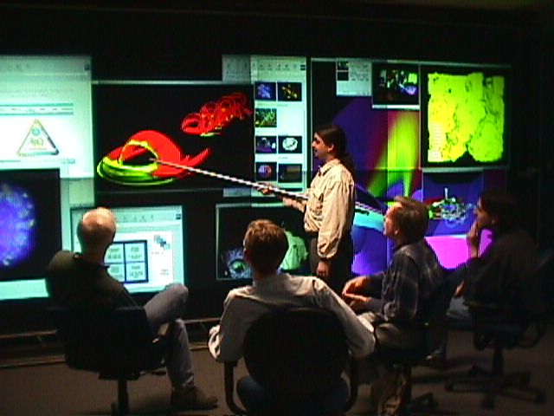Figure 5. Users listen to a presentation given on the ActiveMural. The presentation includes large images, web pages, visualization applications, and PowerPoint slides.

Exploiting Display Abstractions. Applications that are written to an abstract presentation or display layer (e.g., OpenGL) can be run on tiled displays by using a special implementation of the rendering or display pipeline that intercepts data and routes data to an appropriate processor. There are multiple approaches to this technique that use parallel instantiations of the rendering processes and partition image space, to more complex structures that virtualize the stages of the pipeline and load balance across available display or rendering processors. Princeton has exploited this for OpenGL. Depending on the architecture of the image generator (distributed memory vs. shared memory), this may require substantial interprocessor communication and thus require high-performance interconnect. This technique has permitted very high performance graphics applications to run in real time on tiled displays and permits the direct comparison of tiled displays with other multipanel display systems such as the CAVE.

Specific Applications for Tiled Display. Work has begun on developing applications specifically for tiled displays. Stanford, Princeton, and Livermore are experimenting with approaches to manage display window resources and abstractions that are appropriate for large-format and multiple-display channels [Humphreys99, Li00, Schikore00]. Key challenges are portability to multiple configurations and geometries, decoupling of window and display resource management from specific devices and interfaces, virtualization of display resources, and support for new types of user interface mechanisms. Tiled displays and, in particular collections of tiled displays with arbitrary geometries and display orientations (e.g., room with walls, tables, etc. all being active display surfaces) represent a new type of application interface, and dramatic progress seems possible here in the next few years.

Conclusions

Tiled display technologies offer a range of opportunities for exploring scalable, high-resolution, large-format displays, for applications ranging from smart information murals to collaboration walls to high-resolution scientific visualization. Significant progress has been made in understanding the technological challenges relating to screens, projectors, distributed graphics environments, and integration into seamless systems. By exploiting commodity technologies for creating image tiles (off-the-self projectors and consumer-driven screen materials) and commodity image-generation technology (PC clusters with commodity graphics acceleration), these devices should become increasingly affordable and increasingly useful as additions to the range of next-generation displays for building active spaces.

Acknowledgments

The authors acknowledge Mike Papka, Joe Paris, and Justin Binns at Argonne for their help with the Futures Lab ActiveMural project and Kai Li, Tom Funkhouser, and the Scalable DisplayWall group at Princeton University for insightful discussions and sharing of ideas and technology. We also acknowledge the DOE Office of Science and the DOE ASCI VIEWS program for providing support and motivation for some of this work.

References

[Chen00a] Yuqun Chen, Douglas W. Clark, Adam Finkelstein, Timothy Housel, and Kai Li, "Methods For Avoiding Seams On High-Resolution Multi-Projector Displays Using An Un-calibrated Camera," Technical Report TR-618-00, Department of Computer Science, Princeton University, April 2000.

[Chen00b] Yuqun Chen, Han Chen, Douglas W. Clark, Zhiyan Liu, Grant Wallace, and Kai Li, "Software Environments For Running Desktop Applications On A Scalable High-Resolution DisplayWall," Technical Report TR-619-00, Department of Computer Science, Princeton University, April 2000.

[Childers00] Lisa Childers, Terry Disz, Mark Hereld, Randy Hudson, Ivan Judson, Robert Olson, Michael E. Papka, Joe Paris, and Rick Stevens, "ActiveSpaces on the Grid: The Construction of Advanced Visualization and Interaction Environments”, in Simulation and Visualization on the Grid, eds. B. Engquist, L. Johnsson, M. Hammill, and F. Short, Springer-Verlag, 2000.

[Cruz-Niera92] Cruz-Neira, C., Sandin, D.J., DeFanti, T.A., Kenyon, R., and Hart, J.C. “The CAVE, Audio Visual Experience Automatic Virtual Environment.” Communications of the ACM, June 1992, pp. 64-72.

[Czernuszenko97] Marek Czernuszenko, Dave Pape, Daniel Sandin, Tom DeFanti, Gregory L. Dawe, and Maxine D. Brown, “The ImmersaDesk and InfinityWall Projection-Based Virtual Reality Displays,” Computer Graphics, 31(2):46-52, May 1997.

[EVL] University of Illinois at Chicago Electronic Visualization Lab,
http://www.evl.uic.edu/EVL/index.html.

[Fakespace] Fakespace (Pyramid Systems),
http://www.fakespace.com/.

[Friesen00] Jerrold A. Friesen and Thomas D. Tarman, “Remote High-Performance Visualization and Collaboration”, IEEE Computer Graphics and Applications, July, 2000.

[Fox00] Armando Fox, Brad Johanson, Pat Hanrahan, and Terry Winograd, “Integrating Information Appliances into an Interactive Workspace”, IEEE Computer Graphics and Applications, June, 2000.

[FuturesLab] Argonne National Labs, ActiveMural, http://www.mcs.anl.gov/fl/activemural/.

[Gropp94] William Gropp, Ewing Lusk, and Anthony Skjellum, Using MPI: Portable Parallel Programming with the Message-Passing Interface, MIT Press, 1994.

[Hereld00] Mark Hereld, Ivan R. Judson, Joseph Paris, and Rick L. Stevens, “Developing Tiled Projection Display Systems”, Proceedings of the Fourth International Projection Technology Workshop, IPT2000, eds. Carolina Cruz-Neira, Oliver Riedel, Andreas Rossler, 2000.

[HP] HP's Immersive Workspace, using Panoram Technologies PanoWall,
http://www.hp.com/visualize/products/immersive/index.html.

[Humphreys99] Greg Humphreys and Pat Hanrahan, “A Distributed Graphics System for Large Tiled Displays”. In Proceedings of IEEE Visualization 1999. October , 1999.

[InfoComm] International Communications Industry Association, Inc. InfoComm International 2000, Anaheim, CA, June 15-17, 2000.
http://www.infocomm.org/.

[Inova88] Peter Inova, “Seamless Video Display”, US Patent #4,974,073, filed January 14, 1988, issued November 27, 1990.

[IPSI] IPSI – I. L. Darmstadt and and DynaWall,
http://www.darmstadt.gmd.de/IPSI/cospace2-projects-iland.html.

[JenMar] JenMar Visual Systems, BlackScreen™,
http://www.jenmarvs.com/.

[Li99] Kai Li and Yuqun Chen, “Optical Blending for Multi-Projector Display Wall System”. In Proceedings of the 12th Lasers and Electro-Optics Society 1999 Annual Meeting. November 1999.

[Li00] Kai Li, Han Chen, Yuqun Chen, Douglas W. Clark, Perry Cook, Stefanos Damianakis, Georg Essl, Adam Finkelstein, Thomas Funkhouser, Timothy Housel, Allison Klein, Zhiyan Liu, Emil Praun, Rudrajit Samanta, Ben Shedd, Jaswinder Pal Singh, George Tzanetakis, and Jiannan Zheng, “Early Experiences and Challenges in Building and Using a Scalable Display Wall System”, IEEE Computer Graphics and Applications, July, 2000.

[Lyon85] Lyon, Paul. “Edge-blending Multiple Projection Displays On A Dome Surface To Form Continuous Wide Angle Fields-of-View,” pp. 203-209. Proceedings of 7th I/ITEC, 1985.

[Lyon84] P. Lyon and S. Black, “A Self-Aligning CRT Projection System with Digital Correction,” SID Digest 1984.

[Majumder00] Aditi Majumder, Zhu He, Herman Towles, Greg Welch , "Color Matching of Projectors for Multi-Projector Displays" in EUROGRAPHICS '2000, M. Gross and F.R.A. Hopgood (Guest Editors),Volume 19, (2000).

[Mayer96] Theo Mayer, “White Paper on Arrayed Video Projection”, SPIE: International Society for Optical Engineering, January 30, 1996.

[PowerWall] University of Minnesota, PowerWall, http://www.msi.umn.edu/Projects/woodward/powerwall/powerwall.html.

[DataWall] MIT Media Lab, DataWall,
http://vlw.www.media.mit.edu/groups/vlw/DataWall-overview.htm

[MSX] Microsoft X-Box game console,
http://www.xbox.com/.
[OpenProjector00] ASCI Advanced Projector Workshop, San Diego, CA, February 24-25, 2000.

[Panarom] Panoram Technologies,
http://www.panoramtech.com/.

[Princeton] Princeton University, Scalable Display Wall, http://www.cs.princeton.edu/omnimedia/.

[Raskar98] Ramesh Raskar, Greg Welch, Matt Cutts, Adam Lake, Lev Stesin, and Henry Fuchs, “The Office of the Future: A Unified Approach to Image-Based Modeling and Spatially Immersive Displays”. In Proceedings of ACM SIGGRAPH 98, pp179-188, 1998.

[Raskar99] R. Raskar, M. S. Brown, R. Yang, W.-C. Chen, G. Welch and H. Towles. “Multi-Projector Displays Using Camera-Based Registration.” In Proceedings of IEEE Visualization 1999, October 1999.

[ROME] AFRL ADII Group, Interactive DataWall, http://www.if.afrl.af.mil/programs/ADII/.

[Samanta99] Rudro Samanta, Jiannan Zheng, Thomas Funkhouser, Kai Li, and Jaswinder Pal Singh, “Load Balancing for Multi-Projector Rendering Systems”, SIGGRAPH/Eurographics Workshop on Graphics Hardware, August 1999.

[Schikore00] Daniel R. Schikore, Richard A. Fischer, Randy Frank, Ross Gaunt, John Hobson, Brad Whitlock, "High-resolution multi-projector display walls and applications", IEEE Computer Graphics and Applications, July 2000.

[Schroeder98] Will Schroeder, Ken Martin, and Bill Lorensen, The Visualization Toolkit 2nd Edition, Prentice Hall, 1998.

[SGI] http://www.sgi.com/realitycenter/, SGI Reality Center.

[Sony] Sony Playstation 2 game console,
http://www.scei.co.jp/ps2/index2.html.

[Stanford] Stanford Interactive Workspaces Project, Information Wall,
http://www-graphics.stanford.edu/projects/iwork/.

[Stewart] Stewart Filmscreen Corporation,
http://www.stewartfilm.com/.

[Surati99] R.Surati, Scalable Self-Calibrating Display Technology for Seamless Large-Scale Displays. Ph.D. thesis, Massachusetts Institute of Technology, 1999.
[Trimension] Trimension, http://www.trimension-inc.com/.

[UNC] UNC Telepresence Group,
http://www.cs.unc.edu/~mcmillan/telep.html.

[VNC] Virtual Network Computing,
http://www.uk.research.att.com/vnc/.

[Wei00] B. Wei, C. Silva, E. Koutsofios, S. Krishnan, and S.C. North, “Information Visualization with Large Displays”, IEEE Computer Graphics and Applications, July, 2000.

