Argonne National Laboratory

Argonne, IL 60439 USA

ANL/CGC-009-0601

Climate Modeling at the Regional Scale*
by
John Taylor,^{1,2} Jay Larson,¹ and Sheri Voeltz¹

¹Mathematics and Computer Science Division
²Environmental Research Division

Climate and Global Change Series
No. ANL/CGC-009-0601

To appear in special issue of International Journal Environmental Science and Pollution Research

June 2001

jtaylor@mcs.anl.gov
http://www-climate.mcs.anl.gov/

*This work was supported in part by the Office of Biological and Environmental Research, U.S. Department of Energy, under Contract W-31-109-ENG-38.

Argonne National Laboratory, with facilities in the states of Illinois and Idaho, is
owned by the United States Government and operated by The University of Chicago under the provisions of a contract with the Department of Energy.

Argonne National Laboratory, with facilities in the states of Illinois and Idaho, is
owned by the United States Government and operated by The University of Chicago under the provisions of a contract with the Department of Energy.

DISCLAIMER
This report was prepared as an account of work sponsored by an agency of the United States Government. Neither the United States Government nor any agency thereof, nor The University of Chicago, nor any of their employees or officers, makes any warranty, express or implied, or assumes any legal liability or responsibility for the accuracy, completeness, or usefulness of any information, apparatus, product, or process disclosed, or represents that its use would not infringe privately owned rights. Reference herein to any specific commercial product, process, or service by trade name, trademark, manufacturer, or otherwise, does not necessarily constitute or imply its endorsement, recommendation, or favoring by the United States Government or any agency thereof. The views and opinions of document authors expressed herein do not necessarily state or reflect those of the United States Government or any agency thereof, Argonne National Laboratory, or The University of Chicago.

Writers wishing to cite the work described in this preprint are urged to contact the author to determine whether its publication has appeared in the open literature. When possible, citation of the published version of this work is preferred.

Climate Modeling at the Regional Scale

by

John A. Taylor, Jay Larson, Sheri Voelz

Abstract. At Argonne National Laboratory we have developed a high-performance regional climate modeling system based on the NCAR MM5v3.4 mesoscale weather forecasting model. The Argonne system currently includes a Java-based interface to allow rapid selection and generation of initial and boundary conditions, a high-performance version of MM5v3.4 modified for long climate simulations on supercomputers (including Argonne’s 512-processor Linux cluster, Chiba City), an interactive Web-based analysis tool to facilitate analysis and collaboration via the Web, and an enhanced version of the CAVE5d software capable of working with large climate data sets. We illustrate the application of this modeling system to the study of the climate of the U.S. Midwest. In particular, we investigate the role of model resolution in predicting extreme events, such as “Hurricane Huron” event of 11-15 September 1996. We have performed a series of “Hurricane Huron” experiments at 80, 40, 20, and 10 km grid resolution over an identical spatiotemporal domain. We conclude that increasing model resolution in our regional climate simulations leads to dramatic changes in the vertical structure of the simulated atmosphere, producing significantly different representations of rainfall, wind velocities, and other parameters critical to the assessment of impacts of climate change. Future climate simulations at regional resolution could provide a much more realistic basis for the assessment of the impacts of future climate change on both natural and human systems.

Keywords: climate change, Climate Workbench, extreme weather events, regional climate modeling, visualization

1. Goal and Scope

A recent IPCC report on the Regional Impacts of Climate Change [1] concluded:

The technological capacity to adapt to climate change is likely to be readily available in North America, but its application will be realized only if the necessary information is available (sufficiently far in advance in relation to the planning horizons and lifetimes of investments) and the institutional and financial capacity to manage change exists.

IPCC [1] also acknowledged that one of the key uncertainties that limit our ability to understand the vulnerability of subregions of North America to climate change, and to develop and implement adaptive strategies to reduce vulnerability, is the lack of accurate regional projections of climate change, including extreme events. In particular, we need to account for the physical-geographic characteristics that play a significant role in the North American climate (e.g., the Great Lakes, coastlines, and mountain ranges) and also properly account for feedback between the biosphere and atmosphere [1]. These constraints on regional climate prediction apply equally well to other regions of the world.

The potential impacts of global climate change have long been investigated based on the results of climate simulations using global climate models with typical model resolutions of the order of hundreds of kilometers [2,3]. However, the assessment of the impacts of climate change at the regional and local scales will eventually require predictions of climate change at the ~1-10 kilometer scale. Model predictions from global climate models with such high resolutions are not likely to become widely available in the near future. It is also likely that only a few climate centers will be capable of performing the long-duration global climate model runs required for climate impact assessments.

Accordingly, at Argonne National Laboratory we have begun developing a regional climate simulation capability for high-performance computers with the long-term goal of linking the predictive global climate modeling capability with the impact assessment and policymaking communities. The primary technical challenge is to downscale global climate model output to the regional scale. Our initial focus area has been the Midwest region of the United States; however, the methods developed here can be applied equally well to any other region of the earth.

2. Methods

The regional climate simulation system at Argonne currently includes the following (see http://www-climate.mcs.anl.gov):

- A Java-based interface to allow rapid selection and generation of initial and boundary conditions necessary for regional climate modeling.
- A high-performance version of MM5v3.4 modified to enable long climate simulations on supercomputers, including Argonne’s Chiba City, a 512-processor (500 MHz Pentium III) Linux cluster.
- An interactive Web-based analysis tool to facilitate analysis and collaboration via the Web, which enables anyone with access to the Internet to gain access to the output of model runs.
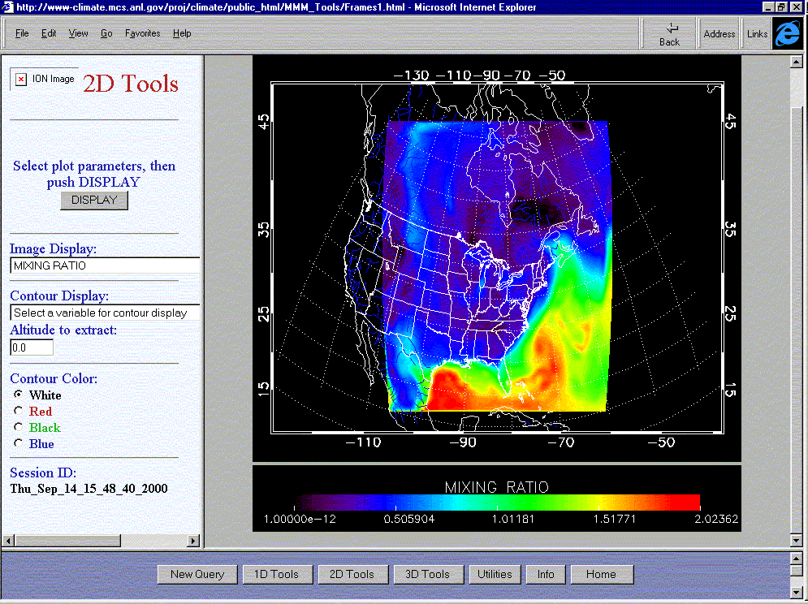
- An enhanced version of the CAVE5d software capable of working with large climate data, which greatly facilitates the analysis climate model output.

The model used in this study was the Pennsylvania State University/National Center for Atmospheric Research (PSU/NCAR) fifth-generation mesoscale model (MM5). In brief, MM5 is a three-dimensional, nonhydrostatic, elastic mesoscale model. It uses finite differences and a time-splitting scheme to solve prognostic equations on an Arakawa type-B staggered grid. Its vertical coordinate, though defined as a function of the reference-state pressure, is similar to a terrain-following coordinate. For case studies, MM5 employs observed wind, temperature, and humidity as the initial and boundary conditions and incorporates realistic topography and sophisticated physical processes to represent the appropriate forcing for the development of the observed weather systems. These physical processes include clouds; long- and shortwave radiative processes; and surface fluxes of heat, moisture, and momentum. A more detailed description of MM5 is provided by Chen and Dudhia [4], Chen et al. [5], Dudhia [6], and Grell et al. [7] .

To facilitate research collaboration, we have developed a Web-based application tool that enables access, via a Web browser, to the output of regional climate model runs using the MM5 system. Figure 1 illustrates a typical session. The Web browser uses the native MM5 data format, thus avoiding the need to store duplicate copies of model output, and works efficiently with gigabytes of data. The Web tool was developed by using IDL/ION software and can be accessed at our Web site. An enhanced version of this Web tool is under development.

Fig. 1. Web interface displaying the water vapor mixing ratio data from a “Hurricane Huron” simulation. All plots are computed online as required.

3. Results and Conclusions

An intense cutoff low developed over the Great Lakes region during the period 11-15 September 1996. The system eventually developed an eye over Lake Huron and spiral convection bands producing intense rainfall and wind speeds in excess of 75 mph. While over Lake Huron the low-pressure system intensified, with lake surface temperatures observed to fall 4-5º C during this period. Given the similarity in appearance in satellite photographs to a hurricane and to the process of development of a Hurricane, this unique Great Lakes weather event was termed “Hurricane Huron” [8].

We have performed preliminary model runs in climate mode using the latest release of the MM5 modeling system (V3.4) looking at extreme events. Mesoscale-resolution climate models provide a consistent framework for us to investigate the link between incoming solar radiation, climate, and extreme weather. The following series of experiments were undertaken in order to illustrate the importance of enhanced model resolution for simulating the weather, climate, and atmospheric transport processes that will impact on extreme weather events.

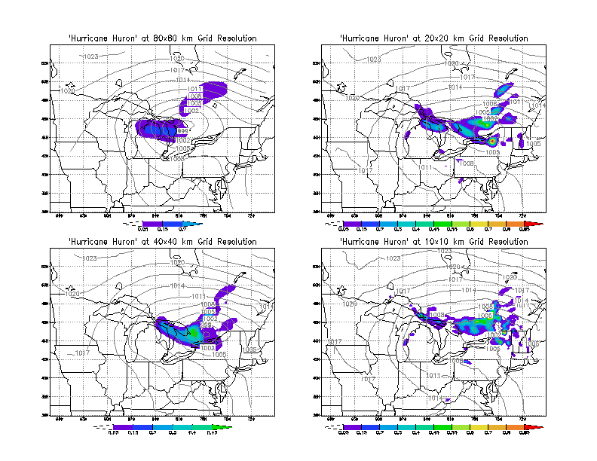
Fig. 2. Wind speed and surface pressure for hour ending 12Z 11 September 1996 at 80, 40, 20, and 10 km grid resolution. Wind speeds intensify, and the formation of a well-defined eye of the low-pressure system are evident as we go to higher grid resolutions.

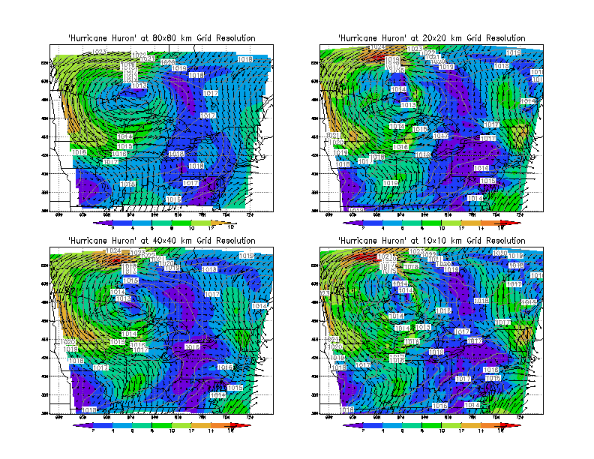

We have performed four simulations of “Hurricane Huron” for the period 6-15 September 1996, at a range of model grid resolutions (80, 40, 20, and 10 km) over an identical 2000x2000 km region centered over Lake Huron. By using an identical spatiotemporal domain, we can study the effect of grid resolution on the evolution of the model simulation. This experiment will help us understand the role that grid resolution plays in the simulation of extreme events such as “Hurricane Huron.” We use NCAR/NCEP Reanalysis Project wind fields to provide boundary and initial conditions.

Figure 2 illustrates the results of modeling an intense cutoff low that developed over the Great Lakes region during the period 11-15 September 1996. In the model simulations the low-pressure system eventually developed an eye, with spiral convection bands producing intense rainfall and high wind speeds. The color contour intervals show wind speed. The contour intervals are identical for all simulations. Arrows represent wind speed and direction and, for clarity, have been plotted at the 80 km grid resolution only, for all plots. Wind speeds increase by up to a factor of 2 as we increase grid resolution from 80 to 10 km.

Figure 3 illustrates that the hourly rainfall intensity increases dramatically, by nearly an order of magnitude, as we go to higher resolutions. The pattern of rainfall also changes from broad-scale low-intensity rainfall at 80 km grid resolution to high-intensity rainfall with significant spatial structure associated with formation of rain bands.

Fig. 3. Precipitation and surface pressure for hour ending 12Z 11 September 1996 at 80, 40, 20, and 10 km grid resolution. Precipitation intensifies by nearly an order of magnitude as we go to higher model resolutions and occupies a smaller more sharply defined rain bands. Increasing precipitation intensities will alter the faction of rainfall allocated to storage in the soil (i.e., soil moisture and runoff), which in turn will alter rates of decomposition and photosynthesis (particularly under water-limited conditions), which in turn will affect agricultural production.

In Fig. 4, the scales on the graphs increase by an order of magnitude in going from 80 to 10 km grid resolution. The figure indicates that changes in vertical velocities associated with the higher model resolution probably play an important role in the simulation of the precipitation events presented in Fig. 3. As with precipitation, vertical velocities increase dramatically with increasing grid resolution. We also see the appearance of greater structure in the vertical motions in the atmosphere, in that broad scale vertical motions at 80 km grid resolution are replaced by much more sharply defined, intense vertical motions associated with zones of strong convergence and divergence. This implies that at higher resolutions we are able to better simulate the formation and evolution of rain bands typically associated with such extreme events as “Hurricane Huron.” The substantial difference in vertical motions between the simulations at different grid resolutions also has important implications for the study of atmospheric chemistry and the application of inverse methods to the study of the sources and sinks of greenhouse gases, where vertical motions help determine the concentration of trace gases.

Fig. 4. Vertical velocities (hPas⁻¹) for the hour ending 12Z 11 September 1996 at 80, 40, 20, and 10 km grid resolution at 45º N. Vertical velocities intensify by more than an order of magnitude and penetrate to much greater height in the atmosphere as we go to higher model resolutions, and they occupy more sharply defined regions.

4. Recommendations and Outlook

We have performed preliminary model runs at 80, 40, 20, and 10 km grid resolution in climate mode using the latest release of the MM5 modeling system (V3.4) simulating the extreme Midwest weather event “Hurricane Huron.” We conclude that model resolution plays an important role in determining the key parameters typically used to determine the impact of extreme weather events, such as wind speeds and precipitation rates. Model resolution was also found to have a significant impact on atmospheric vertical motions, affecting precipitation rates and their spatial distribution. Changes in vertical motions with increasing grid resolution could also play a significant role in simulations of atmospheric chemistry and inverse modeling aimed at determining the sources and sinks of greenhouse gases.

We will continue to address the key scientific and computational issues in regional climate modeling [9] and their importance to simulating regional climate, including the following:

- defining and delivering ‘quality’ data products via the Web,
- improving the performance of long-term regional climate simulations, and
- assessing the quality of global climate model inputs and the role of model spinup and climate drift on regional climate simulations.

We also plan to assess the importance of consistent physics, the sensitivity of climate to the lateral boundary conditions, and the effect of two-way nesting. Finally, we need to enhance the model to include better representation of agriculture, natural ecosystems, atmospheric chemistry and biogeochemical cycles of the key greenhouse gases and the role of the oceans and lakes. Future climate simulations at regional resolution, as illustrated above, could potentially provide a much more realistic basis for the assessing the impacts of future climate change on both natural and human systems.

Acknowledgments

We thank the many staff members in the Mathematics and Computer Science Division at Argonne National Laboratory who assisted us in developing the regional climate simulation capability.

References

1. IPCC. 1998. The Regional Impacts of Climate Change, Cambridge Univ. Press, Cambridge, UK.

2. IPCC WGI. 1990. Climate Change: The IPCC Scientific Assessment. R. A. Houghton et al. (eds.), Cambridge Univ. Press, Cambridge, UK.

3. IPCC WGI. 1996. Climate Change 1995: The Science of Climate Change. R. A. Houghton et al. (eds.), Cambridge Univ. Press, Cambridge, UK.

4. Chen, F., and J. Dudhia. 2001: Coupling an Advanced Land-Surface/Hydrology Model with the Penn State/NCAR MM5 Modeling System: Part I: Model Implementation and Sensitivity, Monthly Weather Review, in press. ( See also Pennsylvania State University / National Center for Atmospheric Research, MM5 Home Page http://www.mmm.ucar.edu/mm5/mm5-home.html).

5. Chen, F., K. Mitchell, J. Schaake, Y. Xue, H. L. Pan, V. Koren, Q. Y. Duan, K. Ek, and A. Betts. 1996. Modeling of Land-Surface Evaporation by Four Schemes and Comparison with FIFE Observations. J. Geophys. Res. 101: 7251-7268.

6. Dudhia, J. 1993. A Nonhydrostatic Version of the Penn State/NCAR Mesoscale Model: Validation Tests and Simulation of an Atlantic Cyclone and Cold Front. Mon. Wea. Rev. 121: 1493-1513.

7. Grell, G. A., J. Dudhia, and D. R. Stauffer. 1994. The Penn State/NCAR Mesoscale Model (MM5). NCAR technical note, NCAR/TN-398+STR, 138 pp.

8. Miner, T., P. Sousounis, G. Mann, and J. Wallman. 2000. “Hurricane Huron,” Bulletin of the American Meteorological Society, February.

9. Giorgi, F., and L. O. Mearns 1999. Introduction to Special Section: Regional Climate Modeling Revisited, J. Geophys. Res. 104: 6335-6352.

