Developing Tiled Projection Display Systems

Mark Hereld¹, Ivan R. Judson¹, Joseph Paris¹, Rick L. Stevens^{1, 2}

{hereld, judson, paris, stevens}@mcs.anl.gov

Mathematics and Computer Science Division
Argonne National Laboratory¹

Computer Science Department
University of Chicago²

Motivation
Tiled displays are an emerging technology for constructing high-resolution semi-immersive visualization environments capable of presenting high-resolution images from scientific simulation [EVL, PowerWall]. In this way, they complement other technologies such as the CAVE [Cruz-Niera92] or ImmersaDesk, [Czernuszenko97], which by design give up pure resolution in favor of width of view and stereo. However, the largest impact may well be in using large-format tiled displays as one of possibly multiple displays in building “information” or “active” spaces that surround the user with diverse ways of interacting with data and multimedia information flows [IPSI, Childers00, Raskar98, ROME, Stanford, UNC]. These environments may prove to be the ultimate successor of the desktop metaphor for information technology work.
Immersive display systems that can deliver high resolution to a group of viewers need to cover a large area with lots of pixels. Tiling displays together to create a single seamless image is one potentially economical way to do this, provided that the integration methods used to build the array up from single units scale favorably. It is currently feasible to deliver 20 Mpixels or so to an area 16 feet by 8 feet with relatively inexpensive components. Such systems afford the unprecedented and compelling ability to view huge data sets from a distance of 6 feet or so, taking in a large swath of rendered representational reality, and in a few short seconds step closer to examine minute details at considerable resolution. Our goals when building tiled display systems are to have:
- A single seamless large display system, with 5 – 20 million pixels,
- Automated or semi-automated setup and maintenance systems,
- Inexpensive component technologies, utilizing commodity hardware wherever possible,
- Flexibility in input signals, so we can be driven by expensive rendering hardware systems (SGI) and by inexpensive clusters of commodity computers using game-based video adapters,
- Scalable solutions to the problems encountered when tiling projectors.

How far into the future will tiling techniques be useful? To help us think about this question, we have tried to imagine a natural limit to the number of pixels one might want to show in a workspace. Consider creating a single image using either a modest number of yet-to-be-developed projectors with extraordinary resolution, or a difficult-to-underestimate number of modest resolution projectors. The display area might be 24 feet wide and 8 feet tall – a human scaled device that would invite a small group of collaborators to interact with one another and with the rendered reality. We might naturally limit the resolution to that which corresponds to high-quality print material or photographs which today is approximately 1200 dpi. To achieve that level of resolution across a large-scale display surface during the next decade is likely to require the use of even more aggressive tiled display technologies. While we ultimately believe a more integrated display system (e.g. organic LEDs) or a type of more freeform display system will supplant tiled display systems, we also believe this technology to be significant for quite some time into the future. Current packaging systems for tiled displays make it somewhat difficult to build compact or wrap around displays that will ultimately be needed for tiled immersive display systems, we believe the prototype systems described here are a contribution in that direction.

Background, Challenges, and Experiments
Building immersive tiled displays involves solving a set of problems that are not addressed by other immersive system designs. These include (1) choice of screen materials and support structures, (2) choice of projectors, projector supports, and optional fine positioners, (3) techniques for integrating image “tiles” into a seamless whole, (4) interface devices for interaction with applications, (5) display generators and interfaces, and (6) display software environment.
Most commercially available large video display systems are not designed to satisfy the goals of the immersive display system. Rather than increase the resolution, they make a standard resolution signal viewable in large area formats by scaling or replicate. Recent work on tiled display systems by a number of groups is surveyed and summarized in a topical issue of IEEE Computer Graphics and Applications [Fox00, Friesen00, Hereld00, Li00, Schikore00, Wei00].
In the following we discuss key areas of concern in developing practical tiled display systems: tile alignment, image overlap blending, color gamut matching, intensity falloff correction, and distortion correction. In each area we will give background, discuss major challenges, and describe experiments that we have been pursuing to characterize the problems and find solutions.

Tile Alignment
In practice, it is difficult to achieve subpixel alignment even with fine adjustment in each dimension. MIT and UNC have developed software approaches to automatically “distort” the images prior to projection to match edges using calibrated cameras [Surati99, Raskar99]. Princeton has extended the ideas to work with uncalibrated cameras [Chen00a]. This technique is used in addition to mechanical alignment. University of North Carolina’s Office of the Future Group are exploring physical “freeform” projector placement and are handling image alignment completely in software [Raskar98, Raskar99].
Projector alignment must be accurate, stable, and inexpensive. Current low cost commodity projectors can be purchased for about $5,000. Supporting hardware such as positioners should cost a fraction of this in order to keep overall costs low. The pixels on the ActiveMural are about 1 mm in size. To preserve the native resolution of the single tiles we need to control the position and drift to within about a tenth of that.
We have designed a practical and inexpensive 6D positioner so that projectors can be aligned quickly and accurately. The adjustment screws are placed to ensure simple and intuitive relationships between adjustment and effect. The kinematic design of the contact points enables repeatable and stable adjustments. Component count and complexity is kept low in the present design to help keep manufacturing costs low. The design is available for others to utilize to either fabricate or refine.
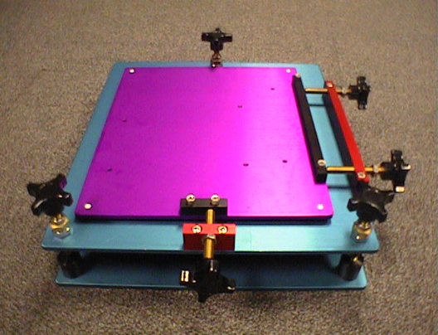
Figure 1. A projector positioner designed and fabricated by Argonne National Laboratory.
We have measured the sensitivity of image shape (keystoning) and alignment on the screen to changes in the positioner screws. Adjustments as fine as 0.1 mm at a projection distance of 70 or so inches are possible.
We have also measured the stability of the projected image relative to the fixed the screen over a range of time scales from 1/15th of a second up to 5.5 hours. Experiments to extend these measurements to days, weeks, and months are underway. On these timescales, the combination of shelving, positioners, and screen frame proves to be very stable. We place the upper limit to drift at 0.08 mm/hour at the screen (or less than about 0.1 pixel / hour).

Image Overlap Blending
Overlapping image tiles and tapering the brightness of the image from each projector can result in a smooth intensity transition from tile to tile. This effect can be achieved in signal electronics [Panoram, Trimension] or in software [Surati99, Raskar99]. As has been pointed out in the literature [Chen00a], unvignetted light from the projector results in a brighter-than-black level in and around the projected image. Overlapping or even abutting such images results in a bright region that can only be eliminated by adding baffling to the light path. One approach, referred to therein as aperture modulation interposes a baffling window between the projector and screen so as to remove this stray light while simultaneously grading the light from one projector so that it’s overlap with it’s neighbor results in a continuous and smooth transition.
Residual misalignment, image zoom error, and distortion also drive our design to include blending (either hardware or software). An added benefit of overlapping and blending adjacent projectors is that these problems are somewhat ameliorated by the soft averaging of errors. In both of our tiled display systems we have incorporated optical blending. For most purposes we find that the distance from the projector to the blending mask hardware is not a critical parameter. Accordingly, we have designed a very inexpensive system of adjustable bars based on off-the-shelf lightweight extruded aluminum components. The systems are easy to assemble and easy to adjust. Furthermore, we have experimented with falloff compensation using alpha masks computed to compensate for the falloff as viewed from a fixed position.

Gamut Matching
Projector color temperature, gamma, and intensity vary not only from unit to unit, but over time as well. For large-arrays it becomes nearly impossible to converge color adjustments manually. Several groups have developed automatic or semiautomatic color-matching techniques that use colorimeter or digital camera inputs and closed-loop optimization algorithms to calibrate and correct the illumination reaching the screen. Groups at UNC [Majumder00] and Princeton [Li00] have reported methods for correcting the image computationally before sending it to the projectors, while we [Hereld00] and LLNL [Schikore00] are developing techniques for adjusting the projector characteristics.
Traditionally, color matching has been very important in the publishing sector, but considerably less so in scientific visualization applications. When several projectors are arranged to simulate a single large display the color mismatch is not only noticeable, it reduces the effect of immersion since it causes the users to perceive the tiling in the display system. Inexpensive and scalable solutions to problem of matching color response of tiles are as yet unavailable. Even very expensive projectors require regular and time-consuming calibration adjustments.
In the area of color matching and calibration much work has been done in desktop publishing (and other production) arenas. Well-developed systems are beginning to mature for characterizing different devices and matching the image perceived – all of this under the banner of ‘color management systems’. Corporate consortia have evolved various standards that look like they are proliferating [ICC]. These systems target high fidelity reproduction of images as they pass through scanning, desktop displays, and different printing phases. None of the methods are targeted at displays utilized for real-time visualization applications. Nor do they address simultaneous calibration of more than one of device, for high fidelity side-by-side comparison. The basic components might be available, but will probably require modification to most effectively address tiled displays.
We have been studying two approaches to solving this problem. First, we are studying image-based automatic real-time calibration of the entire tiled display using inexpensive commodity camera, acquisition, and computing hardware. And, second, we are working on designs for future commodity projectors that feature modular open design to enable configurable in-projector frame-buffer processing, internal calibration sensors, and swappable optical subsystems.
We have surveyed consumer grade digital cameras and video cameras (both analog and digital) for use as color gamut matching sensors. The digital still camera market is only just now beginning to supply cameras with the desired properties: computer controllable, fully ‘manual’ operation for simultaneous control over exposure time and aperture setting, high speed image download (firewire or USB). Until now, such features were available only at the highest end, the so-called professional models. In the analog video camera plus frame grabber solution, it has been equally difficult to find cameras with the right properties.
We worked on methods based on a very inexpensive setup, one that relied on an unmodified low cost video camera. Automatic gain control and fixed integration time were serious impediments. By defeated the AGC, following instructions from the manufacturer in Taiwan, we were able to extract accurate and precise measurement of R, G, and B components. Out of the full range of 256 binary codes in each channel, a single pixel in a single image frame can be read to an accuracy of about 3 digital units. Modest averaging in time or over several pixels results in very accurate measurements. Furthermore, we have determined that much of the noise is correlated in time for each of the three colors, and is therefore amenable to further reduction.
Using the projector’s serial interface we have developed codes to change some of the projector configuration settings, and used this infrastructure to experiment with feedback systems involving cameras, network communications, multi-platform distributed control programs, and simple algorithms to feedback sensor information to drive projector matching.

Intensity Falloff Correction
The falloff of a projector is the difference in perceived brightness across the projected image. Since commodity projectors are designed and sold primarily for single unit use, this is one area that the manufacturers tend to relax the quality constraints. Different projection systems have different design considerations that can modify the light sources natural falloff. Some projectors incorporate optical elements to flatten the light falloff before it gets to the active element. In DLP projectors the economical designs of the low cost projectors rely on off-axis optics, early designs did not incorporate any elements to flatten the illumination before the active element. One such projector, the Proxima DX1 is the projector we have in our ActiveMural. This off-axis projection optics distort the shape of the falloff pattern, making it a bit more difficult to correct.
We have investigated image modifications that will alleviate the problems to a degree. In Figure 2 we show the results of one test where we have projected a flat field, from that flat field we have generated a surface that represents the brightness as perceived by a test camera. A contour of the same data is shown in Figure 3.
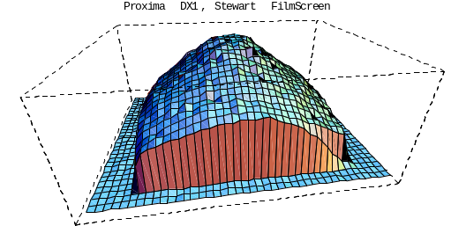
Figure 2. Three-dimensional plot of the falloff of a Proxima DX1 projector through a Stuart FilmScreen™ material, like that used in the CAVE™ walls. The projector is showing a flat white field. The view is from the top middle of the projected image, from in front of the screen.
We have measured the falloff of two different technology projectors (LCD and DMD) on two different types of screen (Stewart and JenMar) in order to compare directly the effects of different projector optics (imposed in part by the underlying light modulation technology) and different screen materials. We find that the DMD-based projector has a significantly sharper falloff than the LCD projector tested. See Figure 7 for the comparison measurements.
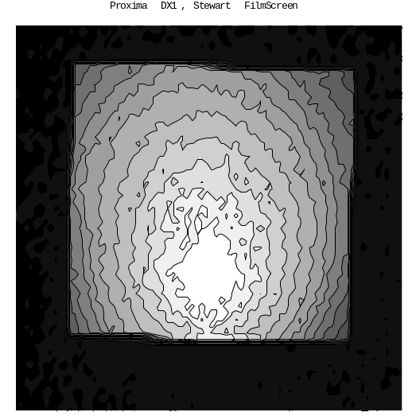
Figure 3. A contour plot of the falloff of a Proxima DX1 projector through Stuart FilmScreen™ material. The projector is showing a flat white field. The view is from in front of the screen surface, orthographic to the center of projection.
Distortion Correction
Commodity projector optics typically have distortions due to both the quality of optical components and to cost-saving design decisions. These distortions cause users to perceive the tiling of the projectors, and can’t be addressed by the projector positioning system. Typical distortions include barreling and stretching of the projected image as the zoom is increased.
In order to reduce the distortion we are developing an automated software system that will measure the distortion of a projector at a given zoom setting, and create an image transformation that will make the image appear undistorted. We are interested in measuring how much data may lost via the transformations needed to correct the projected images.
- Studies software solutions for blending, color matching, and distortion correction.
- Open projector design initiative to develop future projectors with support for solution to these and other problems facing the community.

ActiveMural and μMural
We have built two rear projected tiled display systems, the ActiveMural and the μMural. A quick rundown of each identifies basic configuration issues and compares these two tiled display form factors.
The ActiveMural display area is 16 feet wide and 8 feet high, composed of four, 47.5” wide by 96” long sheets of JenMar Visual Systems BlackScreen™. The four sheets are suspended vertically side by side with a custom frame we designed. They are loaded primarily by gravity. The panel edges are pulled together by springs attached to the bottom of the frame.
The ActiveMural uses a 5 x 3 array of Proxima DX1 projectors, which are native XGA projectors. This endows it with a maximum resolution of 5,120 x 2,304 pixel. The DX1 is based on a single chip micro-mirror array from Texas Instruments.
We typically drive the ActiveMural with one of two sources. Connected to a Linux cluster, with each node in the cluster containing an AGP graphics adapter, we experiment with distributed rendering techniques. When driven by our Onyx2 Infinite Reality™ graphics pipe we run applications designed to run on the CAVE, and applications that need the high performance that the shared memory architecture of the Onyx2 can deliver.
Where possible we have built the ActiveMural from using commodity parts. The projector array is arranged on a lightweight, adjustable, inexpensive, widely available, wire-shelving product known as Metro™. We have constructed an adjustable framework for optical blending of the images from adjacent projectors. It is made structural aluminum extrusion, manufactured by Barrington Automation, and sold by the name FrameWorld.
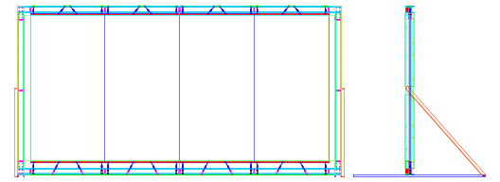
Figure 4. A drawing showing the construction of the frame of the ActiveMural. The blue vertical lines show where the seams in the 4’ wide panels appear.
The steel and aluminum frame, which supports the screen panels, was designed and fabricated by Argonne engineers and shops. The four screen pieces are hung in the frame as shown in the figure below. We have designed into our frame a set of adjustment mechanisms, both along the top and bottom edges of the frame that allow us to minimize the space between the screen pieces.
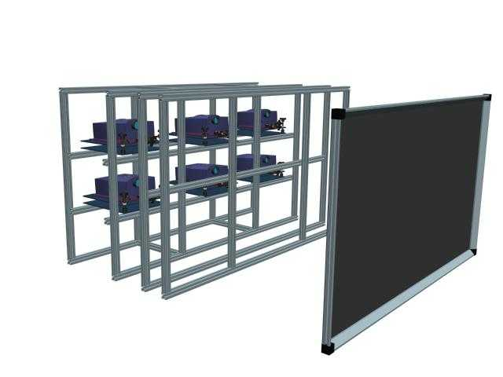
Figure 5. A partial model of the μMural, showing the projection path and the blending hardware. The connections of these parts and the frame that holds this assembly at viewing height is not shown.
The μMural is a six projector portable version of the ActiveMural. It is designed to provide a wide aspect ratio. With overlapped image tiles, its resolution is 2532 by 1407. The projectors in the μMural are Epson 7500c projectors. These are native XGA, 3 panel LCD projectors. Compared to the DMD projectors in the ActiveMural, they have a flatter illumination pattern.
The structure of the μMural is made entirely of aluminum extrusion. The projector positioners sit directly onto mounting plates attached to the extrusion. The screen is framed with extrusion, with this frame it is simple to attach to the rest of the structure. The blending hardware is part of the shelving system, which can be raised and lowered both for shipping and to adjust the height of the screen.
We can drive the μMural projectors from a number of sources: three to six Infinite Reality™ graphics pipes, a single eight-channel pipe, or a cluster of Linux workstations with AGP video adapters. However, it is normally driven by a single six-headed Linux workstation, using the latest XFree86 4.0 release, which incorporates the Xinerama extension to the X server.
The screen material in the μMural is the same BlackScreen™ that we use in the ActiveMural. It is a resolution of greater than 200 lines per inch and a contrast ratio greater than 250 to 1. The ambient light rejection on the screen is greater than 96%. These factors together make the screen bright enough to fully usable in a normal room, with the room set for normal ambient conditions.

Lessons Learned
In this section we collect our experiences into a discussion of observations and lessons learned. They are organized into the same sections that we used to describe our experimental efforts with the addition of a discussion on projectors themselves.

Alignment
Off-axis optics is not a benefit for many (most) tiled display systems. In the case of DMD-based, and probably reflective LCD-based, projectors it is a byproduct of optical needs dictated by the internal layout of crossed beam paths. It complicates the first pass of gross projector alignment by augmenting the effects of keystoning. Taking out keystoning is perhaps the most tedious aspect of projector alignment.

Blending
Optical blending is critical to effective baffling of stray light. We have found that blending works reasonably well for the LCD projectors in our μMural which have gradual intensity falloff compare to DMD projectors we have tested. It has been more difficult for projectors with a rapid and asymmetric falloff. Accurate adjustment of the distance between the projector and the blending masks is not necessary. Simple estimates suffice. Ganged adjustment of the blending edge of several projectors in a line is convenient and practical. Such arrangements also lead to less expensive blending hardware.

Color
Even inexpensive cameras seem to have sufficient dynamic range, noise performance, and repeatability to affect decent (if not excellent) color matching on a tiled array. Important features include:
- Controlled exposure time
- Controlled aperture
- Adjustable zoom
- Adjustable focus
- Fast data path to analyzing computer
It is important to distinguish between two issues: matching versus absolution calibration. The latter is more restrictive and requires a truly calibrated camera. Off-the-shelf solutions for absolute calibration tend to be quite expensive on the one hand, and/or require manual intervention to place calibration head on each tile area. Matching is less demanding, and for most purposes completely adequate.
Another simplification is that our measurements can often include large portions of the tiled display so that comparisons can be made simultaneously within a single frame. Such measurements are considerably more tolerant of fluctuations in the camera’s behavior.
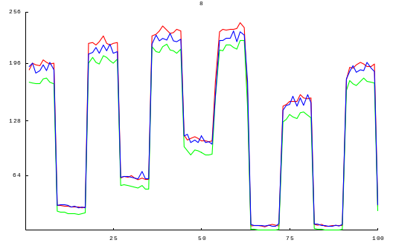
Figure 6. This graph shows the Topica 8002-DS camera response to an alternating, but increasing white signal from the projector. This was captured at fifteen frames per second, for six seconds. The projector held each value for 0.6 seconds.
We have looked for inexpensive colorimeters to provide ground truth for our camera-based colorimetry experiments. For a thousand dollars we found a fairly nice one (Klein LMX92Q). It is hand-held, sticks by suction cup to the screen, and includes useful software for configuring and completing experiments. It is designed for calibrating computer monitors. We have come across two problems that are worth mentioning.
- The sensor head is very sensitive to orientation on the screen since the light power emanating from the projector and screen are far from lambertian. Because of the placement of color sensors in the head, we surmise, this results in chromaticity as well as luminosity dependence on the orientation angle of the head. Consistently using the same orientation is probably sufficient to generate reliable enough measurements using this device.
- The DMD projectors produce fluctuations in intensity and color coming from the rapidly multiplexed light of the projector cause grievous noise problems. The colorimeter samples too quickly to average over these fluctuations appropriately.

Falloff
We have worked with a number of projectors in the laboratory, and a few in sufficient numbers to work with at least small tiled arrays of them. As with most unwanted effects in projected images, they become significantly more perceivable in tiled arrays than when standing alone.
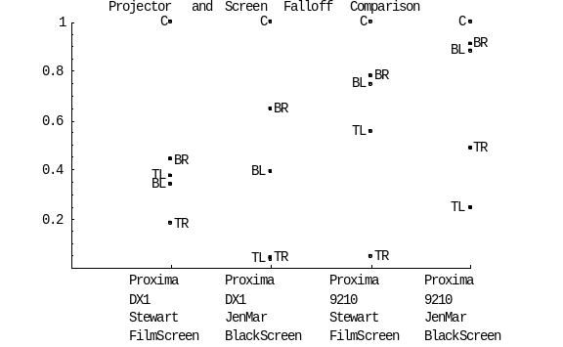Figure 7. This graph compares the falloff of the Proxima DX1 and the Proxima 9210 projectors on both JenMar BlackScreen™ and Stuart FilmScreen™ rear projection surfaces. For each projector we plot the intensity of the center of the peak (C), the top right (TR), top left (TL), bottom right (BR), and bottom left (BL) of the projected image. Values are normalized to the central peak. For a perfect projector and screen all measured intensities would be 1 in this graph.
Off-axis projection exacerbates the falloff problem, too. The edge farthest from the optical axis is very dim, and in symmetrical projector layouts this places the dark and slowly falling edge at the top of a projector next to the bright and rapidly changing bottom edge of its neighbor.

Projectors
Several general observations:
- Flat illumination is a property of the projector design. It varies significantly from model to model in the consumer grade devices. One can pick badly.
- Color is less amenable to selection. In any projector you can expect it to vary significantly, with bulb type and bulb age.
- Bulbs used well past their stated lifetime tend to explode, literally.
- In many ways, off-axis projection is one of the villains for our designs.
- DMD-based projectors make camera-based measurements somewhat difficult because their light is multiplexed by the filter wheel and the pulse code modulation.
- Computer control of projector configuration and internal state is extremely useful.
Many of the problems facing development of tiled displays would benefit from access to one or more of the component subsystems within the projector itself.
- Modified optical components might minimize the adverse effects of off-axis projection.
- Access to the digital data stream driving the LCD or DMD could enable an inexpensive alpha-buffer-buffer based intensity falloff filter with zero impact on rendering applications.
- It could also enable much better control of gamut matching parameters.
- Modest computing power inserted in the internal stream could be employed to digitally correct distortion.
- Fine adjustment of the image position could help in alignment and alignment drift cancellation.
These and other concerns and possibilities have motivated us to instigate a discussion in the community about devising an open projector specification [OpenProjector00].

Future work
A Smart Projector is a projection system tightly coupled with enough computing power to do rendering, image processing, and control of the projection system. A Smart Projector has a network interface through which digital information is delivered to the projector for both control and display. We propose to build a Smart Projector, based upon an open projector specification.

In two areas we will be continuing and extending our work:
- continue development of fast, cheap, integrated, and automated color calibration techniques;
- intensity falloff compensation; and
- camera-based alignment calibration.
We have also begun to work through a design of a folded optical path for a short throw version of the μMural. With an overall depth of about 40 inches, it would fit into an office.
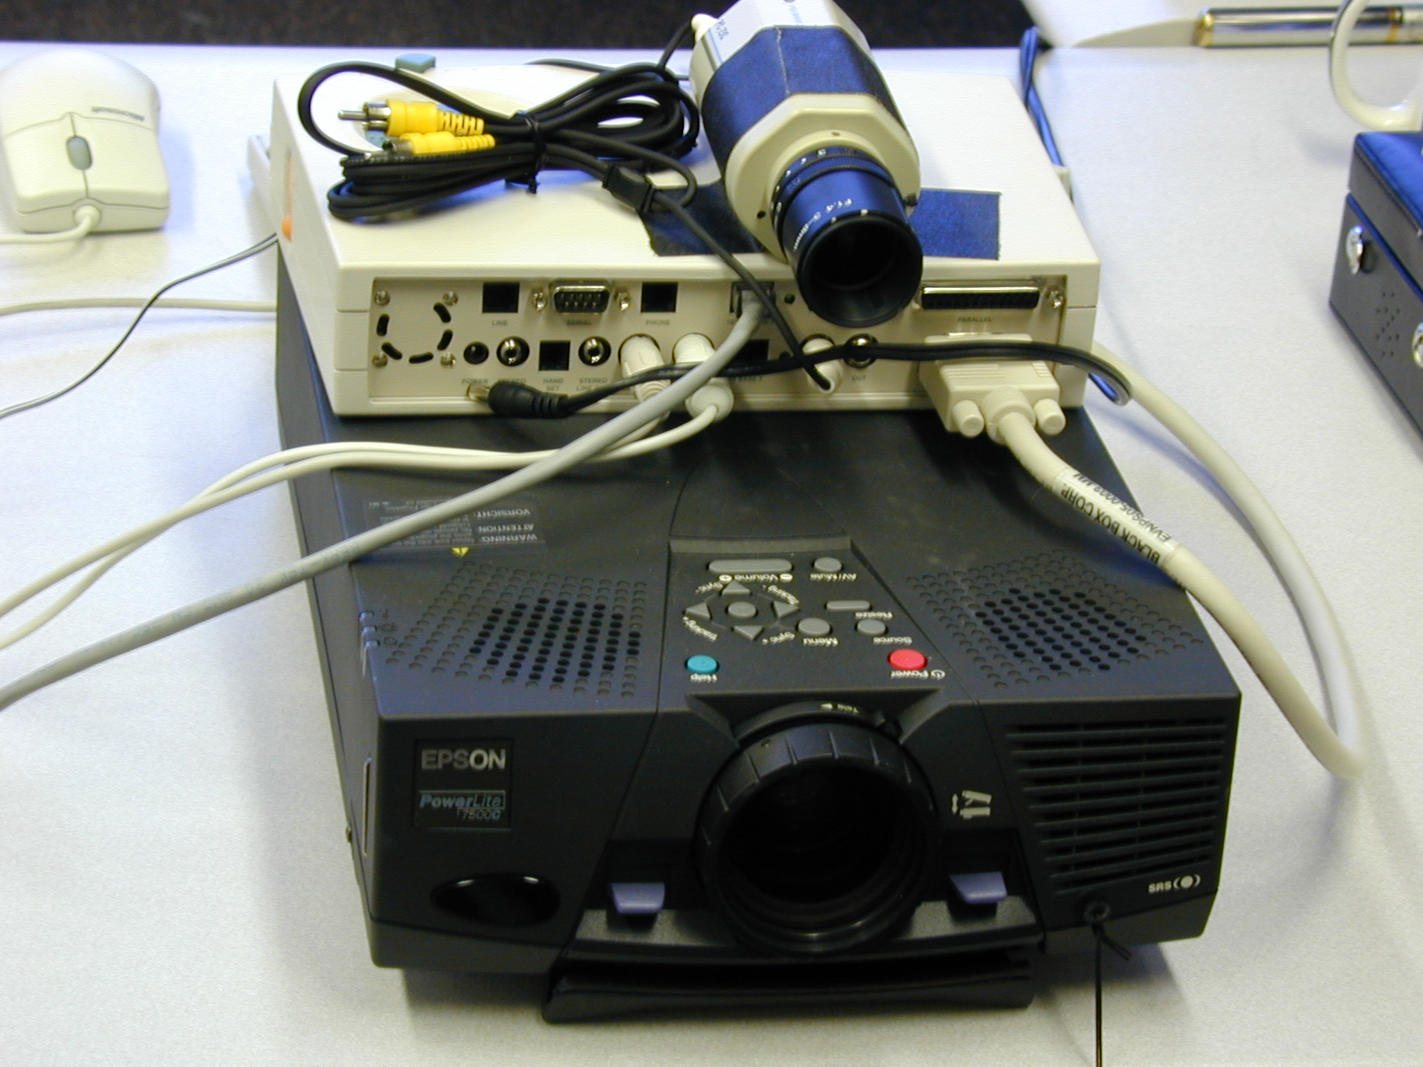
Figure 8. A Smart Projector prototype. The attached NetwinderDM 275 computer drives the Epson 7500c projector. The NetwinderDM reads frames from the camera to do a variety of measurements on the projector.

Acknowledgements
The authors acknowledge Mike Papka and Justin Binns at Argonne for their help with the Futures Lab ActiveMural project and Kai Li, Tom Funkhouser, and the Scalable Display wall group at Princeton University for insightful discussions and sharing of ideas and technology. We also acknowledge the DOE ASCI VIEWS program for providing support and motivation for some of this work. This work was supported by the Mathematical, Information, and Computational Sciences Division subprogram of the Office of Advanced Scientific Computing Research, U.S. Department of Energy, under Contract W-31-109-ENG-38.

References
[Chen00a] Yuqun Chen, Douglas W. Clark, Adam Finkelstein, Timothy Housel, and Kai Li, "Methods For Avoiding Seams On High-Resolution Multi-Projector Displays Using An Un-calibrated Camera," Technical Report TR-618-00, Department of Computer Science, Princeton University, April 2000.
[Chen00b] Yuqun Chen, Han Chen, Douglas W. Clark, Zhiyan Liu, Grant Wallace, and Kai Li, "Software Environments For Running Desktop Applications On A Scalable High-Resolution DisplayWall," Technical Report TR-619-00, Department of Computer Science, Princeton University, April 2000.
[Childers00] Lisa Childers, Terry Disz, Mark Hereld, Randy Hudson, Ivan Judson, Robert Olson, Michael E. Papka, Joe Paris, and Rick Stevens, "ActiveSpaces on the Grid: The Construction of Advanced Visualization and Interaction Environments”, in Simulation and Visualization on the Grid, eds. B. Engquist, L. Johnsson, M. Hammill, and F. Short, Springer-Verlag, 2000.
[Cruz-Niera92] Cruz-Neira, C., Sandin, D.J., DeFanti, T.A., Kenyon, R., and Hart, J.C. “The CAVE, Audio Visual Experience Automatic Virtual Environment.” Communications of the ACM, June 1992, pp. 64-72.
[Czernuszenko97] Marek Czernuszenko, Dave Pape, Daniel Sandin, Tom DeFanti, Gregory L. Dawe, and Maxine D. Brown, “The ImmersaDesk and InfinityWall Projection-Based Virtual Reality Displays,” Computer Graphics, 31(2):46-52, May 1997.
[EVL] University of Illinois at Chicago Electronic Visualization Lab,
http://www.evl.uic.edu/EVL/index.html.
[Friesen00] Jerrold A. Friesen and Thomas D. Tarman, “Remote High-Performance Visualization and Collaboration”, IEEE Computer Graphics and Applications, July, 2000.
[Fox00] Armando Fox, Brad Johanson, Pat Hanrahan, and Terry Winograd, “Integrating Information Appliances into an Interactive Workspace”, IEEE Computer Graphics and Applications, June, 2000.
[FrameWorld] FrameWorld, Barrington Automation, http://www.frame-world.com
[FuturesLab] Argonne National Labs, ActiveMural,
http://www.mcs.anl.gov/fl/activemural/.
[Humphreys99] Greg Humphreys and Pat Hanrahan, “A Distributed Graphics System for Large Tiled Displays”. In Proceedings of IEEE Visualization 1999. October , 1999.
[ICC] International Color Consortium,
http://www.color.org/.
[IPSI] IPSI – I. L. Darmstadt and and DynaWall,
http://www.darmstadt.gmd.de/IPSI/cospace2-projects-iland.html.
[JenMar] JenMar Visual Systems, BlackScreen™,
http://www.jenmarvs.com/.
[Li99] Kai Li and Yuqun Chen, “Optical Blending for Multi-Projector Display Wall System”. In Proceedings of the 12th Lasers and Electro-Optics Society 1999 Annual Meeting. November 1999.
[Li00] Kai Li, Han Chen, Yuqun Chen, Douglas W. Clark, Perry Cook, Stefanos Damianakis, Georg Essl, Adam Finkelstein, Thomas Funkhouser, Timothy Housel, Allison Klein, Zhiyan Liu, Emil Praun, Rudrajit Samanta, Ben Shedd, Jaswinder Pal Singh, George Tzanetakis, and Jiannan Zheng, “Early Experiences and Challenges in Building and Using a Scalable Display Wall System”, IEEE Computer Graphics and Applications, July, 2000.
[Lyon85] Lyon, Paul. “Edge-blending Multiple Projection Displays On A Dome Surface To Form Continuous Wide Angle Fields-of-View,” pp. 203-209. Proceedings of 7th I/ITEC, 1985.
[Lyon84] P. Lyon and S. Black, “A Self-Aligning CRT Projection System with Digital Correction,” SID Digest 1984.
[Majumder00] Aditi Majumder, Zhu He, Herman Towles, Greg Welch , "Color Matching of Projectors for Multi-Projector Displays" in EUROGRAPHICS '2000, M. Gross and F.R.A. Hopgood (Guest Editors),Volume 19, (2000).
[Mayer96] Theo Mayer, “White Paper on Arrayed Video Projection”, SPIE: International Society for Optical Engineering, January 30, 1996.
[PowerWall] University of Minnesota, PowerWall, http://www.msi.umn.edu/Projects/woodward/powerwall/powerwall.html.
[DataWall] MIT Media Lab, DataWall,
http://vlw.www.media.mit.edu/groups/vlw/DataWall-overview.htm
[OpenProjector00] ASCI Advanced Projector Workshop, San Diego, CA, February 24-25, 2000.
[Panaram] Panoram Technologies,
http://www.panoramtech.com/.
[Princeton] Princeton University, Scalable Display Wall, http://www.cs.princeton.edu/omnimedia/.
[Raskar98] Ramesh Raskar, Greg Welch, Matt Cutts, Adam Lake, Lev Stesin, and Henry Fuchs, “The Office of the Future: A Unified Approach to Image-Based Modeling and Spatially Immersive Displays”. In Proceedings of ACM SIGGRAPH 98, pp179-188, 1998.
[Raskar99] R. Raskar, M. S. Brown, R. Yang, W.-C. Chen, G. Welch and H. Towles. “Multi-Projector Displays Using Camera-Based Registration.” In Proceedings of IEEE Visualization 1999, October 1999.
[ROME] AFRL ADII Group, Interactive DataWall, http://www.if.afrl.af.mil/programs/ADII/.
[Samanta99] Rudro Samanta, Jiannan Zheng, Thomas Funkhouser, Kai Li, and Jaswinder Pal Singh, “Load Balancing for Multi-Projector Rendering Systems”, SIGGRAPH/Eurographics Workshop on Graphics Hardware, August 1999.
[Schikore00] Daniel R. Schikore, Richard A. Fischer, Randy Frank, Ross Gaunt, John Hobson, Brad Whitlock, "High-resolution multi-projector display walls and applications", IEEE Computer Graphics and Applications, July 2000.
[Schroeder98] Will Schroeder, Ken Martin, and Bill Lorensen, The Visualization Toolkit 2nd Edition, Prentice Hall, 1998.
[Stanford] Stanford Interactive Workspaces Project, Information Wall,
http://www-graphics.stanford.edu/projects/iwork/.
[Stewart] Stewart Filmscreen Corporation,
http://www.stewartfilm.com/.
[Surati99] R.Surati, Scalable Self-Calibrating Display Technology for Seamless Large-Scale Displays. Ph.D. thesis, Massachusetts Institute of Technology, 1999.
[Trimension] Trimension, http://www.trimension-inc.com/.
[UNC] UNC Telepresence Group,
http://www.cs.unc.edu/~mcmillan/telep.html.
[Wei00] B. Wei, C. Silva, E. Koutsofios, S. Krishnan, and S.C. North, “Information Visualization with Large Displays”, IEEE Computer Graphics and Applications, July, 2000.

